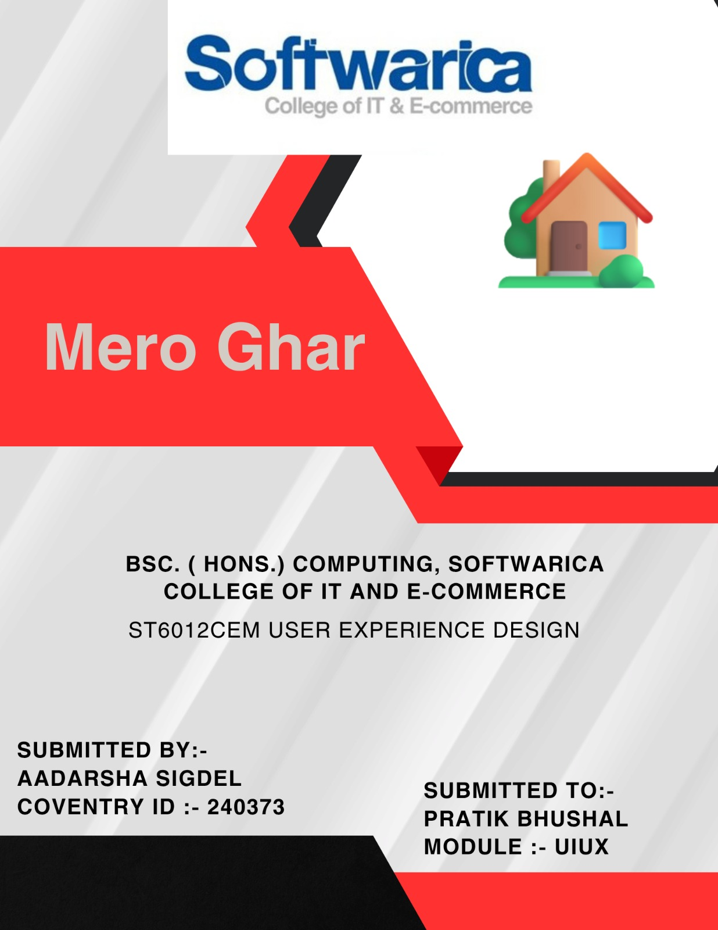

Contents

**MeroGhar – An Airbnb-Style Homestay Booking Platform** 2

**PACT Analysis** 3

**Literature Review** 4

**FACEBOOK MARKETPLACE** 4

**Figure 2: Drawbacks of Facebook Marketplace** 4

**AIRBNB** 5

**REQUIREMENT ANALYSIS** 6

**LOW-FIDELITY PROTOTYPE** 7

**WIZARD OF OZ TESTING** 7

**USER FEEDBACK** 7

**IMPROVEMENTS TO CONSIDER MOVING TO THE NEXT STAGE** 8

**HIGH FIDELITY TESTING** 9

**GUERRILLA FIDELITY TESTING** 9

**USER FEEDBACK FOR HIGH FIDELITY** 10

**GUERRILLA FIDELITY TESTING** 10

**USER FEEDBACK FOR HIGH FIDELITY** 11

**IMPROVEMENTS TO MAKE MOVING FORWARD** 11

**NIELSEN'S 10 HEURISTICS FOR USER INTERFACE DESIGN** 12

**VISIBILITY OF SYSTEM STATUS** 12

**MATCH BETWEEN SYSTEM AND THE REAL WORLD** 12

**USER CONTROL AND FREEDOM** 13

**CONSISTENCY AND STANDARDS** 14

**ERROR PREVENTION AND CONTROL** 15

**RECOGNITION RATHER THAN RECALL** 15

**FLEXIBILITY AND EFFICIENCY OF USE** 16

**AESTHETIC AND MINIMALISTIC DESIGN** 17

**HELP USERS RECOGNIZE, DIAGNOSE, AND RECOVER FROM ERRORS** 18

**HELP AND DOCUMENTATION** 19

**UI Diagram** 20

**User Flow Diagram** 21

**Final Product** 21

**Interaction Design Principles** 22

**Shortest Path** 22

**Crow’s Feet Analysis** 22

**Subjective Constancy** 22

**Law of Closure** 22

**Metaphor** 22

**Design Rule** 22

**Gimmick** 23

**Principle of Least Surprise** 23

**Hick’s Law** 23

**Micro interaction** 23

**Diamond Design Principle** 23

**Conclusion** 23

## **MeroGhar – An Airbnb-Style Homestay Booking Platform**

MeroGhar is a digital homestay marketplace designed for travellers and hosts within Nepal. Modelled on the familiar structure of Airbnb, it simplifies the listing and booking of residential stays while being uniquely optimized for the Nepali market. The platform provides features for users to register as guests or hosts, list and manage properties, browse accommodations, book stays using local or international payment methods, and manage bookings through personalized dashboards. Unlike global competitors, MeroGhar focuses on accessibility, local integration, and affordability, aiming to connect travellers with homestays across both urban and rural regions.

The design of MeroGhar emphasizes streamlined interactions, clear navigation, and localized payment systems such as Khalti and Cash on Arrival. Its interface accommodates users with varying levels of digital literacy, ensuring a user-friendly experience regardless of background. The vision of the application is to support domestic tourism and rural economies while providing a scalable solution for digital accommodation bookings in Nepal.

## **PACT Analysis**

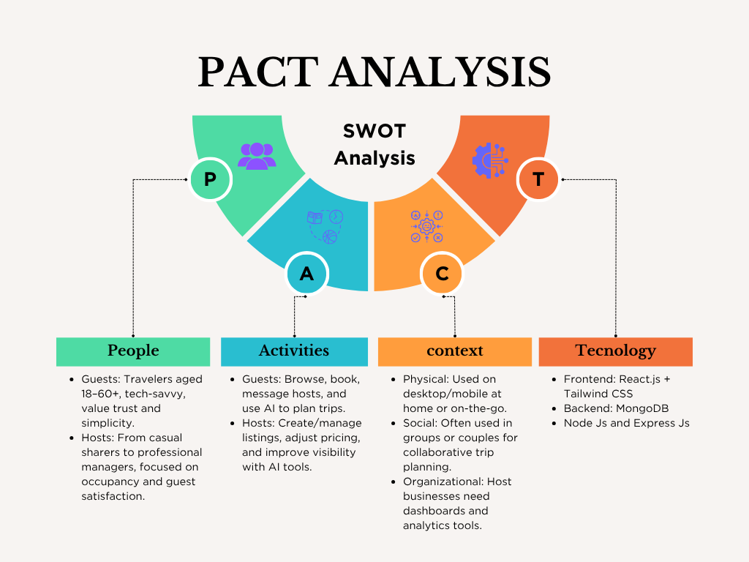

MeroGhar was developed using a PACT (People, Activities, Contexts, Technologies) framework to address the needs of both guests and hosts. Guests—ranging from students to professionals—require a simple, intuitive interface to search and book listings, while hosts—often rural homeowners or small business owners with limited digital exposure—need tools to manage properties, bookings, and availability. Core activities include user registration, listing management, booking, payment, and support access. The platform is optimized for both mobile and desktop use, with special attention to low-bandwidth performance in rural areas. Built on the MERN stack, MeroGhar also integrates Cloudinary for image handling, Khalti and Stripe for payments, and JWT for secure, mobile-first access.

Figure:

## **Literature Review**

Among the digital rental solutions available in the market, informal listing platforms like Facebook Marketplace and large-scale global booking platforms such as Airbnb most closely represent the existing options that MeroGhar aims to improve upon.

## **FACEBOOK MARKETPLACE**

*"Rent Anything, anywhere – Instantly"*

Facebook Marketplace has become a go-to informal platform for Nepali users seeking rental spaces or homestay listings. Its popularity stems from its integration with the social media ecosystem, allowing users to view listings from people in their extended network and negotiate prices directly. Its localized nature and familiarity make it especially attractive to rural hosts and budget-conscious guests.

## **Figure 2: Drawbacks of Facebook Marketplace**

Despite its widespread usage, Facebook Marketplace poses critical limitations for both hosts and guests. The absence of verification mechanisms makes listings prone to fraud and misrepresentation, placing users at financial and personal risk. There is no standardized way to handle bookings, payments, or cancellations, leaving room for disputes and mistrust. Communication remains fragmented and unstructured, relying on Facebook Messenger rather than a centralized platform. Furthermore, the lack of reviews, filters, and structured profiles makes discovery difficult and credibility unverifiable. This creates a highly inconsistent and inefficient experience for both parties.

**MeroGhar**, in contrast, offers a purpose-built alternative tailored specifically for Nepali renters and hosts. It incorporates listing verification, structured property profiles, guest reviews, and secure payment systems. The platform removes the ambiguity of informal platforms by standardizing listings and providing a seamless booking experience. With inbuilt filtering, location-based search, and guest protection policies, MeroGhar ensures trust, efficiency, and safety in a way that informal platforms like Facebook Marketplace cannot.

## **AIRBNB**

*"Belong Anywhere – Globally"*

Airbnb is one of the most recognizable names in the global hospitality industry. It offers a streamlined and professional interface for both hosts and travellers, with integrated identity verification, secure payments, and an extensive review system. Its polished UX, brand reputation, and large user base make it a desirable platform for international and urban travellers.

**Figure 3: Drawbacks of Airbnb**

However, Airbnb’s model often falls short for the specific needs of the Nepali market. The platform’s service fees and pricing model are prohibitive for many budget travellers and small-scale rural hosts. It emphasizes properties with high-quality photos and amenities that many local homes may not meet, making visibility and discoverability difficult for modest listings. Language barriers, policy restrictions, and lack of localization support further alienate Nepali users. Moreover, many Nepali homestays cater to domestic travellers or local events — a use case poorly supported by Airbnb’s international tourism-centric design.

**MeroGhar**, on the other hand, is built with the realities of the Nepali market in mind. It provides an inclusive environment for both urban and rural hosts, supporting low-cost, low-tech property listings without the pressure of professional staging. Its multilingual interface and localized support systems bridge the gap for non-English speaking users. With mobile-first access and integration with local payment gateways like Khalti and eSewa, MeroGhar ensures affordability, accessibility, and local relevance. It offers a scalable solution tailored to the diverse needs of the Nepali population — from college students to rural homestay operators — ensuring no user is left behind.

## **REQUIREMENT ANALYSIS**

The idea for MeroGhar was born out of the everyday challenges faced by Nepali renters and homestay hosts in trying to connect through fragmented and often unreliable digital platforms. Whether it’s a college student seeking affordable accommodation in Kathmandu or a rural homeowner looking to list a homestay for domestic tourists, the process is typically disorganized, informal, and filled with uncertainty. Most users currently rely on basic tools like Facebook groups, word-of-mouth, or general-purpose marketplaces that lack any assurance of authenticity or structured communication. This leaves both guests and hosts vulnerable to scams, miscommunication, and missed opportunities.

MeroGhar aims to resolve these pain points by offering a platform specifically tailored to the Nepali context. From the outset, the vision was to create more than just a listing website — the goal was to develop a complete ecosystem where trust, convenience, and accessibility are prioritized. The platform is designed to accommodate users across a wide digital literacy spectrum, including those in rural regions who may be accessing the service via mobile phones on limited bandwidth.

To ensure the platform meets real user needs, the development followed a **User-Centered Design (UCD)** approach. Extensive research into both guest and host behaviour was conducted to identify key friction points such as lack of transparency, poor filtering mechanisms, and limited payment options. The design process focused on delivering solutions that are intuitive, localized, and scalable. For example, integration with popular Nepali payment systems like eSewa and Khalti ensures financial accessibility, while features such as verified user profiles, language toggling, and responsive design support ease of use for a broad audience.

MeroGhar also benchmarks its features against global and regional platforms, combining the trust-building features of Airbnb (like verified listings and reviews), the simplicity and affordability of platforms like Hamro Bazar, and the mobile-first experience seen in successful South Asian apps. However, its core value lies in serving the local market with tools built specifically for local challenges — ensuring that everyone, from a first-time city renter to a village homestay owner, can use the platform with confidence and clarity.

## **LOW-FIDELITY PROTOTYPE**

The low-fidelity prototyping stage for MeroGhar was conducted to validate fundamental user journeys, interface logic, and the overall structure of information presentation before investing in high-fidelity UI design. This early prototyping step ensured that core functionalities—such as listing discovery, property creation, and booking flow—were clear, accessible, and aligned with real user needs (Nielsen Norman Group, 2023).

## **WIZARD OF OZ TESTING**

To evaluate the usability and intuitiveness of the MeroGhar platform in its conceptual form, a structured **Wizard of Oz** testing approach was used with paper prototypes. Participants included a diverse mix of users: university students seeking budget rentals, rural hosts interested in listing homestays, and working professionals exploring short-term stays. Testing sessions were conducted in a quiet indoor setting using printed wireframes representing various screens of the application—Homepage, Search Filters, Listing Detail, Host Dashboard, and Booking Confirmation.

A facilitator assumed the role of the “system,” manually simulating platform behavior. As users performed tasks such as browsing listings by location, filtering based on budget, creating a new listing, and initiating a booking, the facilitator responded with pre-arranged cards mimicking system feedback. All sessions were recorded using a mobile camera setup to capture both facial expressions and hand movements. Emotional cues (e.g., hesitation or frustration) and navigational errors were carefully logged. After task completion, participants gave open-ended feedback which was thematically analyzed across categories like trust, ease of navigation, and perceived safety.

This round of testing enabled the identification of critical usability concerns and highlighted emotional pain points—particularly for first-time rural hosts and mobile-first users who preferred simpler navigation and clearer calls-to-action.

## **USER FEEDBACK**

The Wizard of Oz test for MeroGhar produced several important insights that informed the next design iteration. Users responded positively to the **localized filtering system**, appreciating that they could search listings by districts, landmarks, or even colleges. The inclusion of payment methods like **Khalti and eSewa** also added a sense of familiarity and convenience, especially for domestic travellers.

However, multiple usability issues and visual gaps were noted. For example, participants found it difficult to differentiate between guest and host roles during onboarding, causing confusion. The host listing form felt overwhelming, particularly for less tech-savvy users. Without guidance or progress indicators, some users abandoned the form midway. Participants also expressed concern about **trust and safety**, especially around listing authenticity—highlighting a need for visible verification badges or “trusted host” labels.

The **booking confirmation screen** was described as “bland and uncertain,” lacking any visual confirmation of success or clear instructions for next steps. On mobile screens, filter buttons and dropdowns felt cramped and unintuitive. Importantly, there was no way for users to **track their bookings or listing views**, which reduced the perceived utility of the dashboard.

Participants also raised concerns about **visual consistency**, noting that some screens used unclear icons, inconsistent font weights, or color schemes that lacked contrast—making the interface harder to scan, especially in low-light conditions common in rural areas.

## **IMPROVEMENTS TO CONSIDER MOVING TO THE NEXT STAGE**

To build trust and reduce confusion, the onboarding flow must be clearly split into **“Guest” vs “Host” journeys**, with simple explanations and visual cues. This will eliminate ambiguity and improve role clarity from the first interaction.

The **listing form** needs to be broken into smaller, manageable steps, with a visible **step tracker** and auto-save functionality. Include contextual tooltips to explain required fields (e.g., location pin, image uploads, amenities) in plain Nepali or English, depending on the user’s language setting.

Introduce a **“Verified Host” badge system** and listing credibility indicators like “Recently Booked” or “Top Rated” to address user concerns about trust and legitimacy. These visual trust markers can significantly enhance confidence during browsing.

Redesign the **booking confirmation screen** to include a friendly illustration, confirmation animation (e.g., checkmark), and next steps—like “View Booking,” “Contact Host,” or “Explore More Listings.” This will improve the closure and usability of the booking process.

To improve usability, implement mobile-first refinements like larger tap targets, sticky filter buttons, and collapsible sections. Ensure all forms have **real-time validation** with micro-interactions such as error highlights or toast messages for confirmation. Introduce **dashboard analytics** for hosts, such as listing views and bookings received.

Finally, apply a **consistent visual language** across all screens. Choose a colour palette with high contrast, clear typography, and uniform iconography to enhance readability and reduce cognitive load. Before moving to high-fidelity prototyping in Figma, these usability, layout, and trust-related adjustments are essential to delivering a reliable and welcoming experience for MeroGhar users.

## **HIGH FIDELITY TESTING**

Following insights gathered from low-fidelity testing and iterative design refinements, MeroGhar transitioned into the high-fidelity stage. A comprehensive prototype was created using **Figma**, incorporating responsive design elements and detailed micro-interactions. The design prioritized adherence to **Nielsen’s 10 heuristic principles**, ensuring clarity, consistency, error prevention, and user control. The high-fidelity prototype aimed to represent the actual platform experience, allowing for realistic user testing in preparation for development.

## **GUERRILLA FIDELITY TESTING**

To evaluate the effectiveness of the MeroGhar high-fidelity prototype, **guerrilla testing** was conducted across multiple environments—including university campuses, co-working spaces, and homestay areas—to engage a diverse user group. Test participants included urban renters, student tenants, and rural hosts with varying levels of digital literacy.

Each session began with a short briefing explaining the voluntary nature of the test, followed by task-based evaluations. Participants were instructed to complete real-world flows such as:

* Searching for a rental in a specific district
* Filtering listings by price and amenities
* Creating a new homestay listing as a host
* Simulating a booking and confirming the reservation
* Viewing listing performance in the host dashboard

The tests were conducted using laptops and mobile phones to ensure responsiveness and accessibility were equally assessed across devices. Facilitators closely observed behaviors, taking note of navigation patterns, moments of confusion, and drop-off points. After the tasks, participants were asked open-ended questions to evaluate their satisfaction with the visual design, ease of use, and perceived trust in the platform.

While some participants were first-time renters unfamiliar with structured booking systems, others were frequent users of digital marketplaces. This variation enabled the collection of layered feedback to inform refinement across different user journeys.

## **USER FEEDBACK FOR HIGH FIDELITY**

After refining the insights from the low-fidelity prototype, the project advanced to the **high-fidelity design stage**. The MeroGhar prototype was developed in **Figma**, focusing on accurate layout, visual consistency, and the seamless flow of essential features—such as browsing listings, host onboarding, booking confirmation, and viewing dashboard activity. The interface was designed following **Nielsen’s 10 usability heuristics** to ensure it was functional, predictable, and accessible for both guests and hosts.

## **GUERRILLA FIDELITY TESTING**

To assess the prototype in real-world settings, **guerrilla testing** was conducted with a cross-section of users in Kathmandu and nearby districts. Test participants included university students looking for rentals, small homestay operators listing their properties, and urban users browsing short stays. Each participant was given a series of structured but realistic tasks, such as:

* Searching listings using district and price filters
* Creating a new property listing as a host
* Booking a stay with check-in and check-out date selection
* Viewing host dashboard entries for listing status
* Switching the interface language between Nepali and English

The prototype was tested on both laptops and mid-range smartphones to evaluate responsiveness. Observers took note of hesitation points, navigation errors, and feedback comments. After completion, participants responded to open-ended questions about clarity, ease of use, and comfort with the overall design.

## **USER FEEDBACK FOR HIGH FIDELITY**

Overall, users praised the **simple and familiar layout**, especially the two-panel structure on desktop and the bottom-tab navigation on mobile. The **listing creation flow** was well received, with users finding the input steps logical and simple to follow. Many hosts noted the clarity in uploading photos and entering property details, although they requested more visual confirmation when a step was completed.

The **language switch** feature between Nepali and English was widely appreciated, particularly by rural hosts who preferred instructions in Nepali. However, a few users were initially unaware of the language toggle, prompting the need for clearer placement or labeling.

Guests found the **booking flow** intuitive, especially the ability to pick dates and see price totals instantly. However, the **booking confirmation screen** felt too plain and lacked a visual confirmation of success. Users recommended adding a simple success message and clearer next-step options such as "Go to Dashboard" or "Return to Home."

In terms of layout, smaller phone users reported minor issues with spacing on the filter menu, where text labels felt cramped. The **host dashboard**, though functional, was considered slightly basic and could benefit from improved spacing and clearer section titles.

## **IMPROVEMENTS TO MAKE MOVING FORWARD**

Based on feedback, the following changes will be made before final development:

* **Font Size & Spacing**: Increase base font size slightly and add spacing between form fields and filter buttons for mobile users, especially on smaller screens.
* **Visual Confirmation**: Add a simple success checkmark and confirmation message on the **booking confirmation screen**, along with a “Return to Home” and “Go to Dashboard” button.
* **Micro Interactions**: Add toast notifications or subtle visual cues (e.g., checkmarks or progress bar) in the **listing creation form** to confirm successful input submission.
* **Language Switch Visibility**: Relocate or highlight the **Nepali-English toggle** button for better visibility, especially for new users unfamiliar with it.
* **Host Dashboard Clarity**: Improve section headers and layout consistency in the dashboard, ensuring that the property name, booking status, and availability are visually distinguishable.

## **NIELSEN'S 10 HEURISTICS FOR USER INTERFACE DESIGN**

Nielsen's 10 Heuristics for User Interface Design are a set of widely recognized principles that serve as a crucial framework for evaluating and improving the usability of digital systems (Nielsen Norman Group, n.d.). Adherence to these heuristics was a foundational part of the MeroGhar design process, ensuring that the final product would be simple, predictable, and accessible—qualities essential for a platform supporting everyday users navigating property rentals and homestay hosting.

## **VISIBILITY OF SYSTEM STATUS**

MeroGhar follows the Visibility of System Status heuristic by giving users immediate and clear feedback during key interactions. For example, when a host submits a property listing or a guest initiates a booking, the system displays a loading indicator and then a confirmation message such as “Listing Created Successfully” or “Booking Confirmed.” In longer multi-step processes like listing creation, form validation and page transitions provide subtle cues that guide users through each step, reassuring them that the system is processing their input. These consistent feedback mechanisms help reduce uncertainty and build trust, particularly for users who may be engaging with an online rental platform for the first time.

## **MATCH BETWEEN SYSTEM AND THE REAL WORLD**

MeroGhar adheres to the Match Between System and the Real-World principle by using language, icons, and structures that reflect everyday user expectations. Labels such as “Create Listing,” “Booking Details,” and “View Dashboard” are used in place of technical jargon, ensuring that users immediately understand the action associated with each button or section.

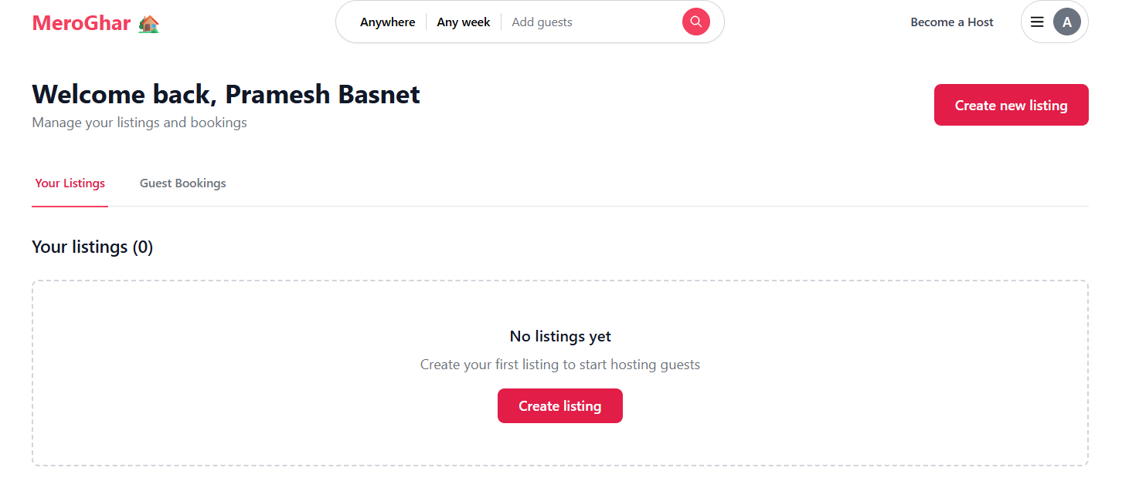Standard icons—such as a calendar for date selection or a house for listings—mirror familiar offline concepts, reinforcing usability. The layout of the homepage and dashboard is also grounded in conventional web patterns, reducing cognitive effort and allowing users to intuitively engage with the platform without requiring prior instruction.

## **USER CONTROL AND FREEDOM**

MeroGhar supports User Control and Freedom by ensuring that users are never forced into irreversible actions without confirmation. During listing creation or while filling out booking forms, users can freely return to previous steps or cancel the process altogether. When users attempt to close or exit without saving, the system prompts them with a clear confirmation message to prevent accidental data loss. This provides a safety net for both hosts and guests, giving them the freedom to explore, revise, or cancel tasks with confidence and without unintended consequences.

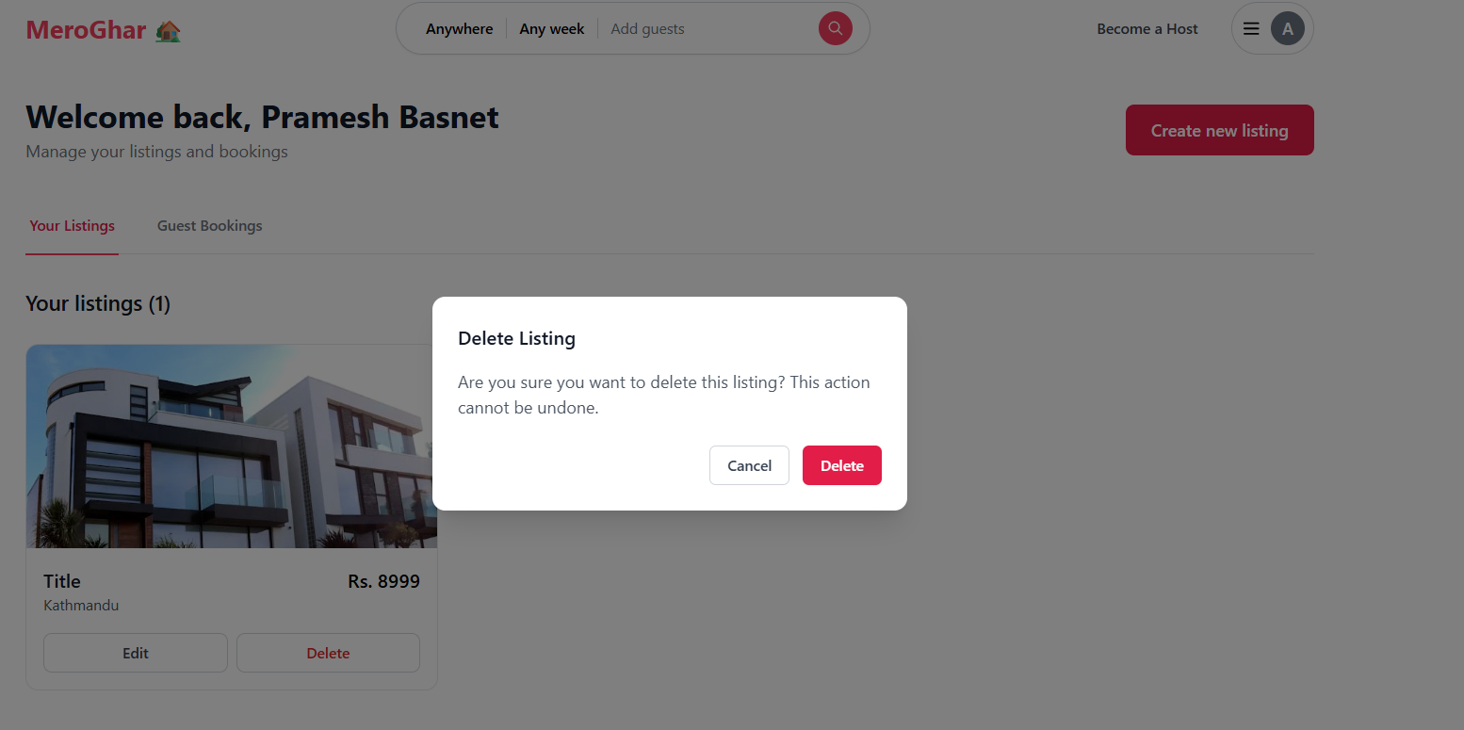

## **CONSISTENCY AND STANDARDS**

MeroGhar maintains a strong internal and external consistency throughout its interface. Internally, all pages follow the same layout logic, using a unified color scheme and consistent typography. Primary actions such as “Save,” “Continue,” or “Book Now” always appear in the same style and position, reinforcing user habits and reducing confusion. Externally, MeroGhar aligns with established digital standards—such as placing navigation links in the top bar on desktop or the bottom navigation on mobile. Familiar conventions like a clickable logo returning to the homepage are preserved across the site, ensuring that users can rely on intuitive expectations without needing to relearn the interface.

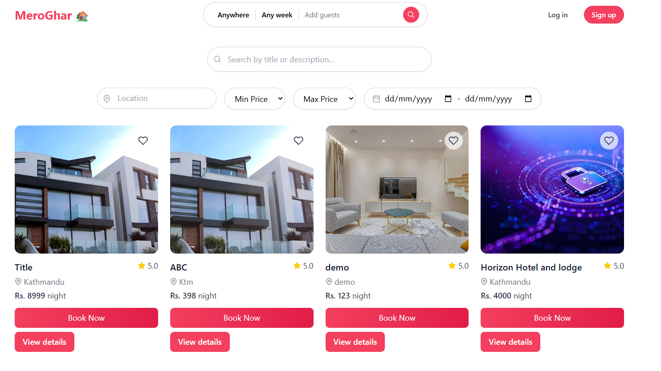

## **ERROR PREVENTION AND CONTROL**

MeroGhar implements the Error Prevention and Control heuristic by helping users avoid mistakes and offering simple mechanisms for recovery when errors occur. All forms include live field validation—if a user leaves a required field blank or inputs invalid data, the system immediately flags the error with a brief message beneath the field, such as “Please enter a valid price.” In more critical operations like submitting a listing or confirming a booking, confirmation dialogs alert users before final actions are processed, minimizing the risk of accidental submission. These safeguards ensure a smooth and frustration-free experience, especially for first-time users.

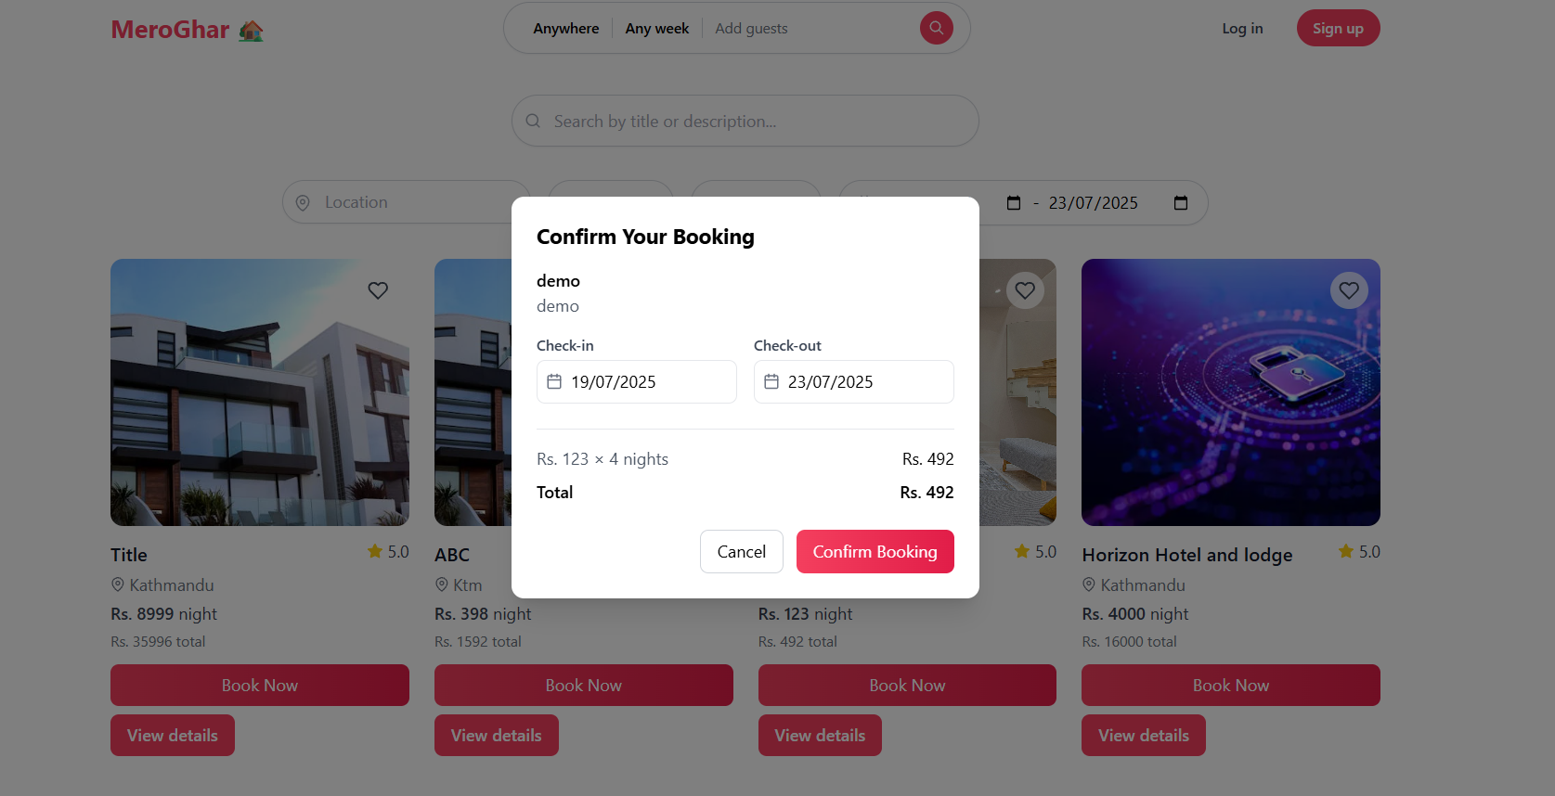

## **RECOGNITION RATHER THAN RECALL**

The Recognition Rather than Recall principle is embedded throughout the MeroGhar interface to reduce the user's memory load. Navigation options such as “Dashboard,” “Bookings,” and “Listings” are always visible and clearly labelled, making it easy for users to move between sections without relying on memory. Within forms, expected input formats are stated directly in the field—for example, “Enter location” or “Upload up to 5 images”—so users know exactly what is required without trial and error. Once a booking is complete or a listing is published, visible confirmation screens guide the user toward their next step with options like “Return to Homepage” or “Go to Dashboard.”

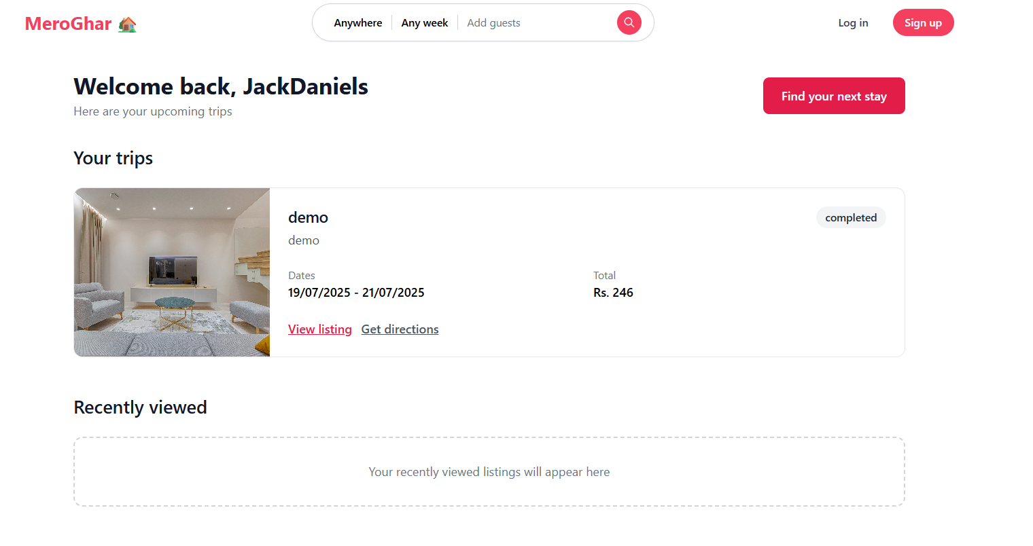

## **FLEXIBILITY AND EFFICIENCY OF USE**

MeroGhar supports both novice and returning users by balancing simplicity and efficiency. First-time hosts are guided through a clear, step-by-step listing process, while more experienced users can access their dashboard immediately to update prices, view booking status, or manage availability. Guests benefit from quick filters like location and price range, allowing them to find relevant listings without navigating complex menus. While the platform does not yet include shortcuts or advanced customizations, the existing flow is streamlined enough to serve users at different experience levels effectively.

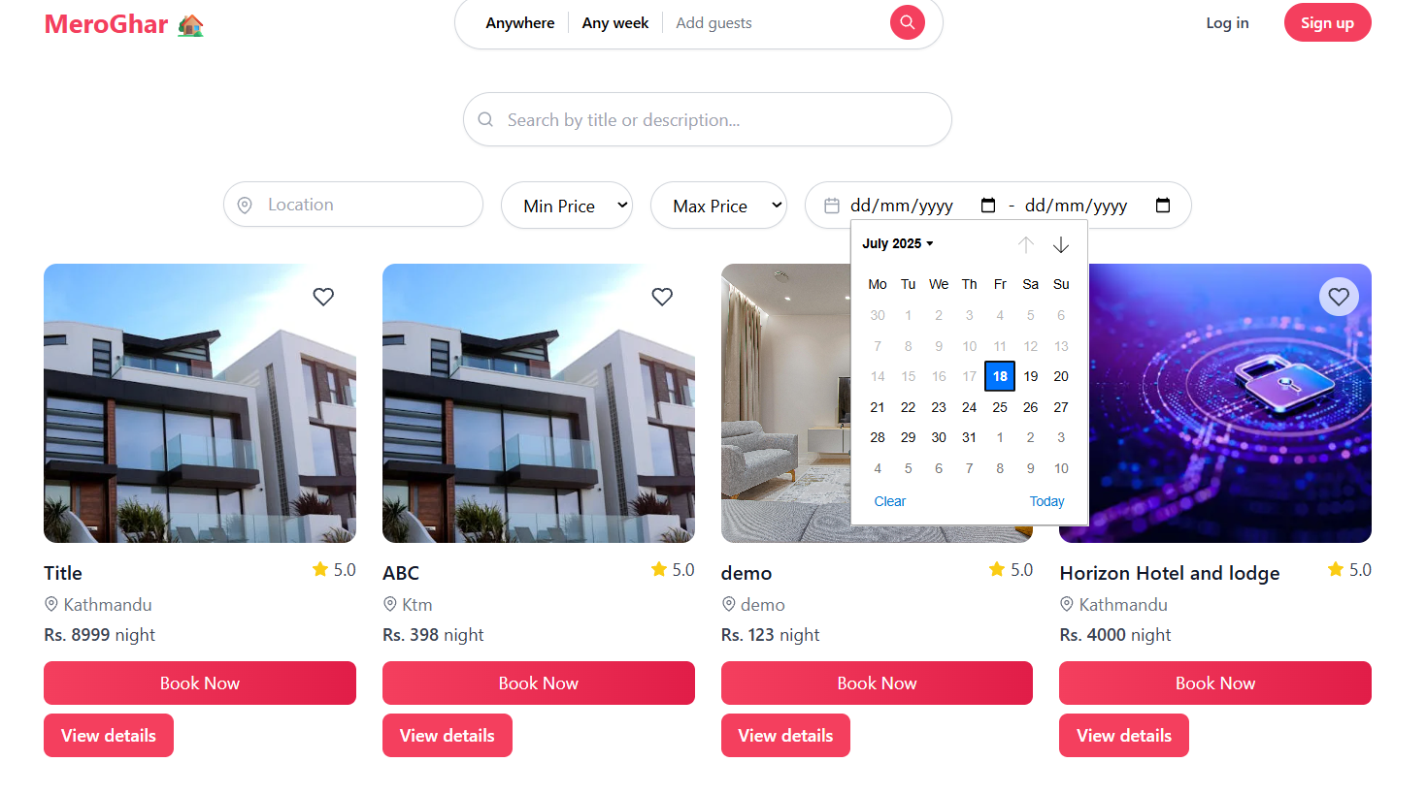

## **AESTHETIC AND MINIMALISTIC DESIGN**

The platform follows the Aesthetic and Minimalist Design principle by maintaining a clean, uncluttered interface. Each page displays only the most relevant information for the task at hand. The homepage shows featured listings in a grid format with concise titles, prices, and preview images. The listing creation form includes only the necessary input fields, spaced generously and grouped logically to avoid cognitive overload. The booking confirmation screen avoids excessive detail, instead presenting just the essential summary of dates, price, and contact options. This visual simplicity ensures that users stay focused and are not overwhelmed by extraneous content.

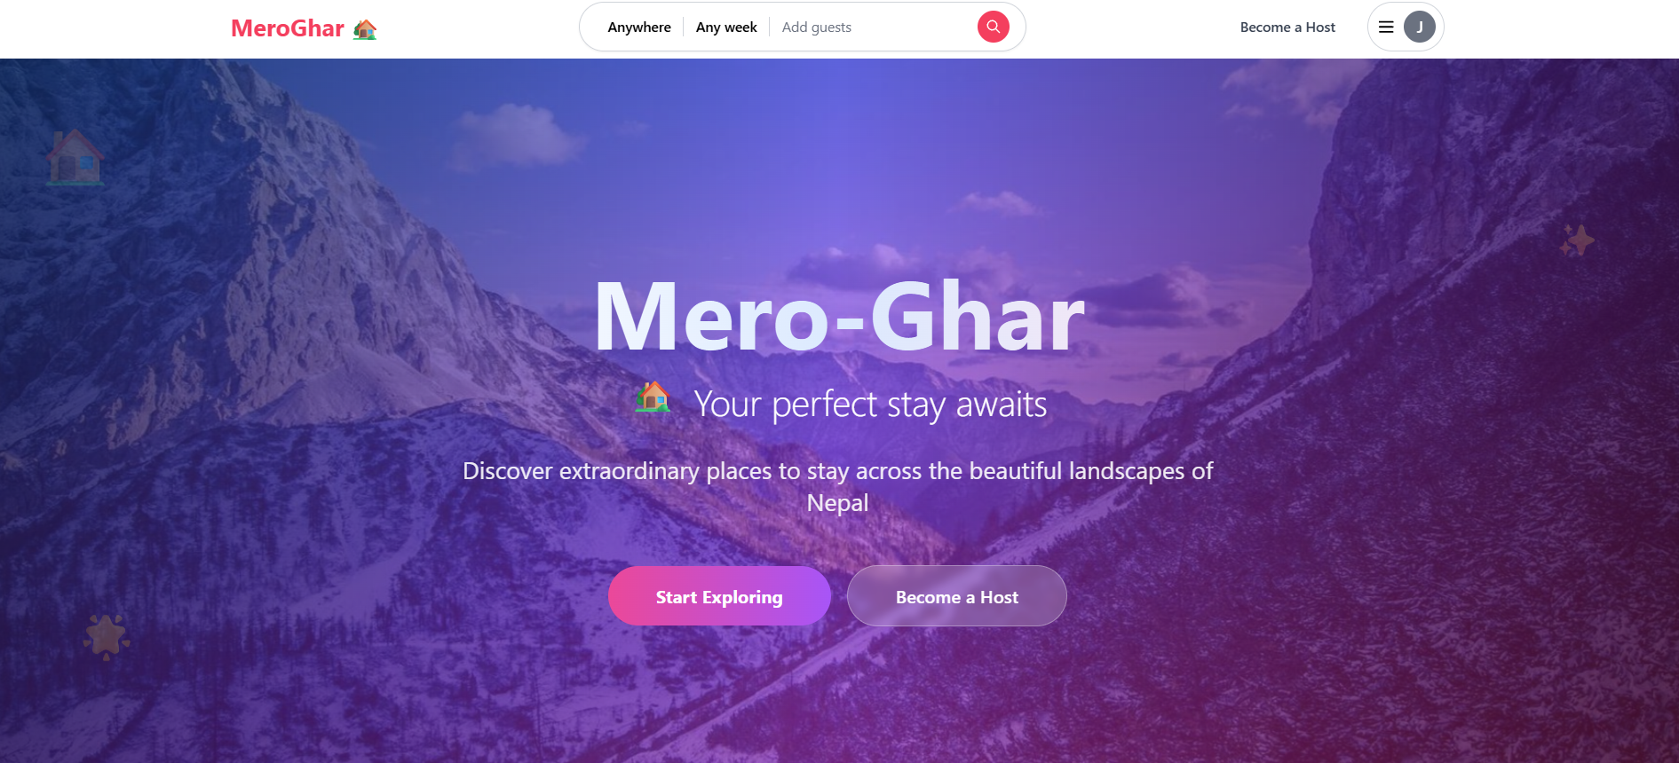

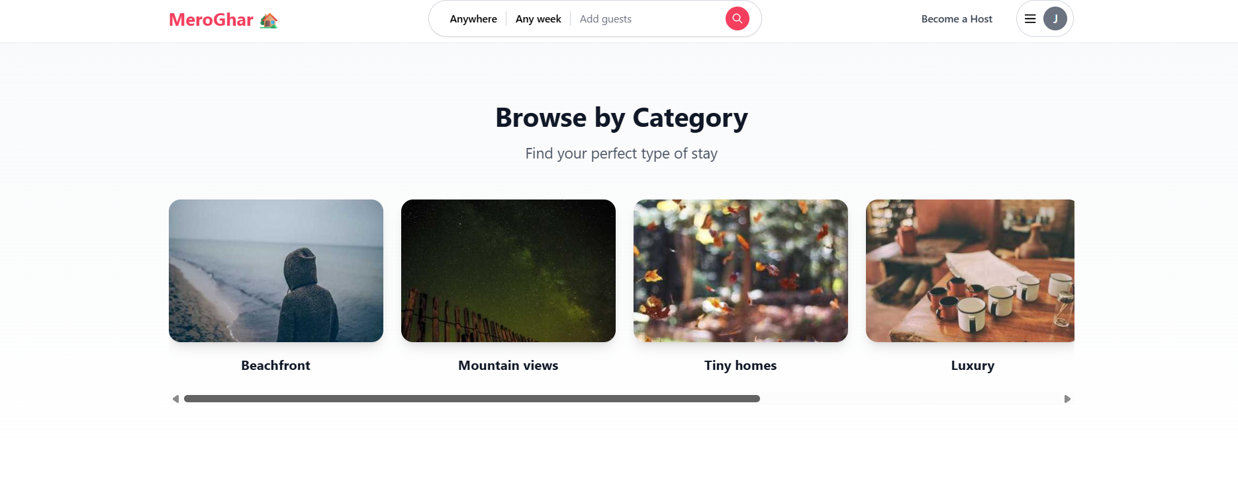

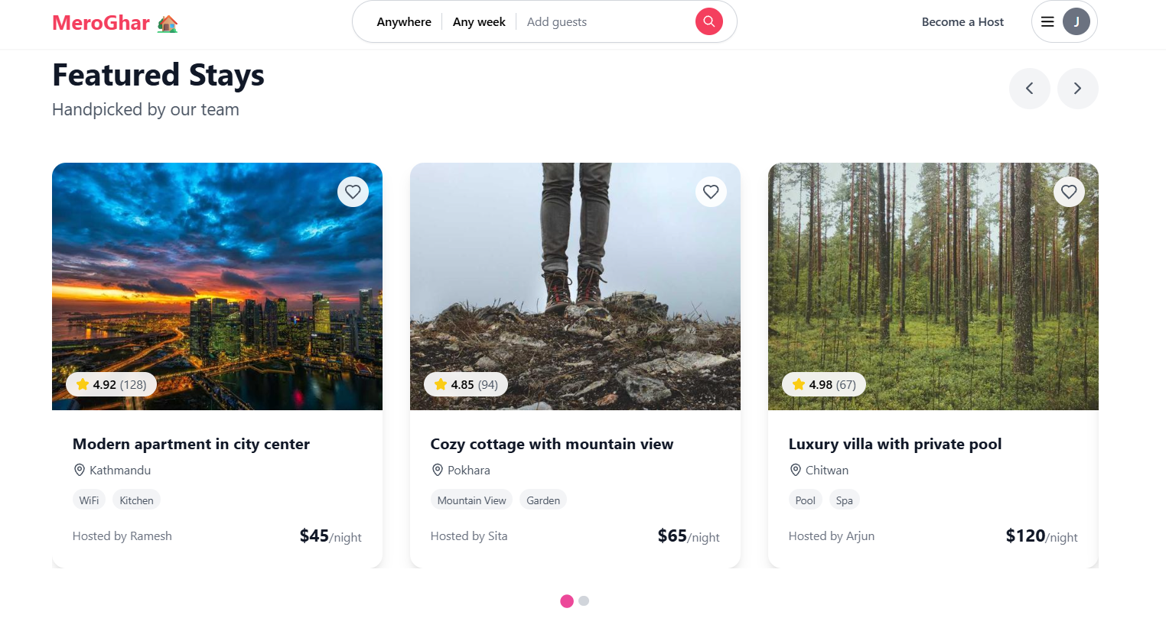

## **HELP USERS RECOGNIZE, DIAGNOSE, AND RECOVER FROM ERRORS**

MeroGhar helps users recover from mistakes by providing clear and actionable error messages in natural language. If a required field is left blank or a file upload fails, the system provides a polite, specific message like “You must upload at least one image” or “Please select a location from the dropdown.” These messages are designed to be friendly and constructive rather than technical or cryptic. By making the problem and the solution immediately understandable, MeroGhar reduces user frustration and supports a more forgiving, error-tolerant environment.

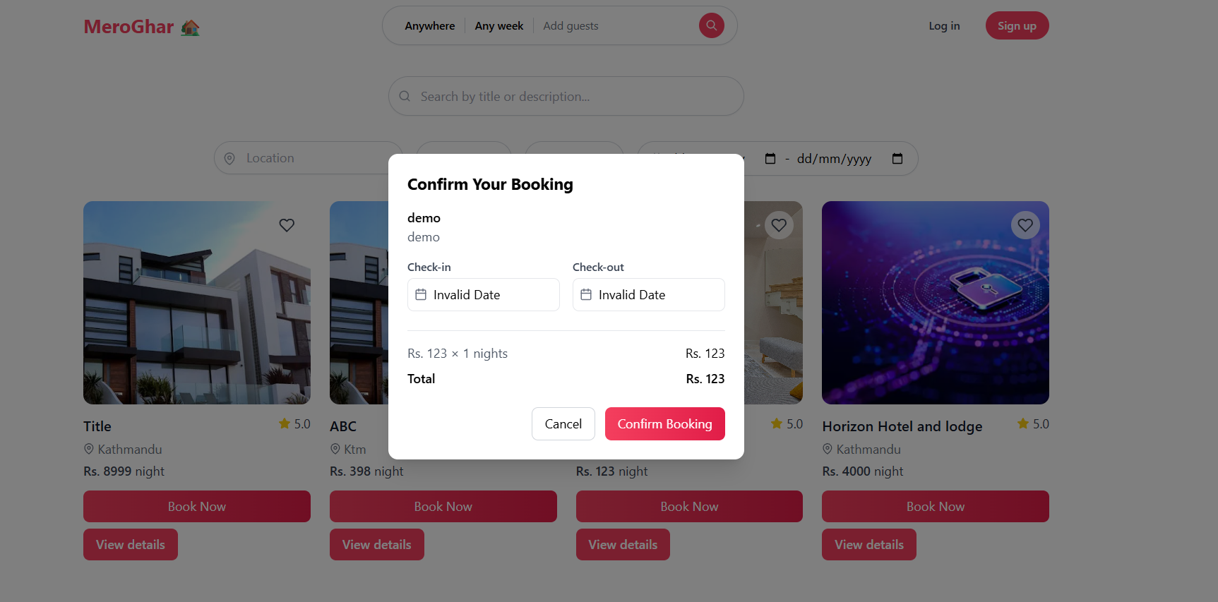

## **HELP AND DOCUMENTATION**

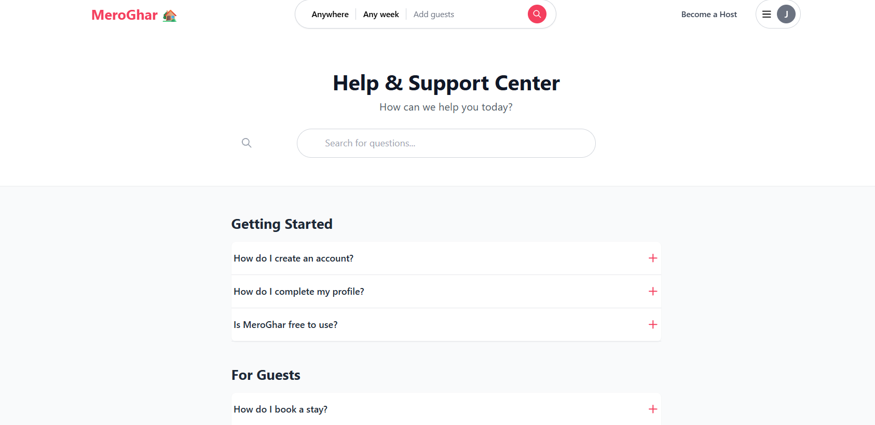

While MeroGhar is designed to be self-explanatory, it includes a basic Help section accessible from the footer or user menu. This section contains a concise FAQ covering common tasks such as how to create a listing, how to make a booking, and how to edit user information. The content is written in plain language and organized under user-centered questions to support task completion. Although the help section is not yet interactive or extensive, its presence ensures that users who need guidance are not left without support.

## **UI Diagram**

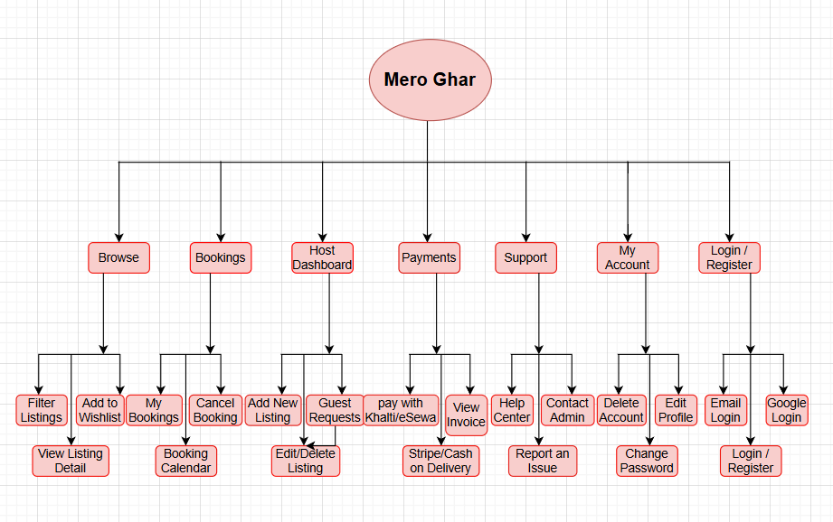

The UI architecture outlines the structure and relationships between different parts of the application. The primary entry point is the homepage, which connects to authentication screens (Login, Signup, Forgot Password). Post-authentication, users are routed to role-specific dashboards.

Guest dashboards include sections for browsing listings, booking history, and support. Host dashboards provide access to create new listings, manage existing ones, and view earnings. A global navbar allows users to switch roles, access settings, and log out. This modular design ensures scalability and clarity.

## **User Flow Diagram**

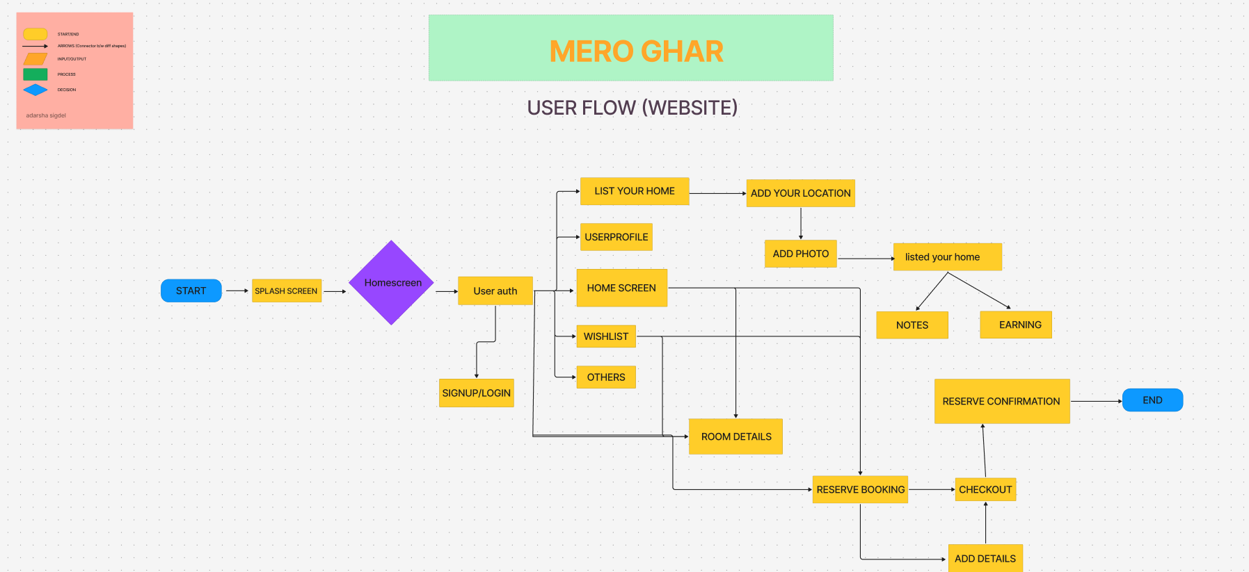

The user flow focuses on the journey a user takes to complete key tasks. A guest typically proceeds from homepage → login → search listings → view listing → select dates → make payment → see confirmation → return to dashboard.

For hosts, the flow follows: dashboard → create listing → fill details → upload images → confirm submission → view live listing. Each step includes feedback mechanisms and error handling to support smooth progression.

## **Final Product**

The final system represents a refined, production-ready version of MeroGhar, developed through iterative design and extensive user testing. Built using the MERN stack, the platform incorporates secure JWT-based authentication, cloud-hosted media handling, real-time form validation, and integration with multiple payment gateways including Khalti, Stripe, and Cash on Arrival. The user interface is fully responsive, ensuring seamless access across both mobile and desktop devices. MeroGhar supports role-based dashboards for guests and hosts, allowing hosts to create listings with image uploads and guests to book properties using an availability-aware engine. An admin panel enables efficient moderation of users and listings, while the overall system aligns with usability heuristics to deliver a highly accessible and intuitive experience.

## **Interaction Design Principles**

**Flat Design**

The interface uses a flat design style, eliminating 3D effects or shadows to maintain clarity and simplicity. Elements rely on colour, spacing, and typography to convey importance and interaction.

**Golden Path**

Guest and host flows were optimized to reduce unnecessary steps. Booking a homestay requires just four clicks post-login. Similarly, creating a listing takes three steps.

## **Shortest Path**

Features like “Book Again” and “Duplicate Listing” shorten the journey for returning users. Saved information is reused across sessions to reduce repetition.

## **Crow’s Feet Analysis**

Points of hesitation (the “feet”) were minimized by reducing ambiguities, such as unclear icons or insufficient confirmation messages. Delightful moments (the “crow’s eyes”) were intentionally emphasized, such as payment success animations and welcome banners.

## **Subjective Constancy**

Layouts and component behavior remain consistent across devices. The placement of key buttons, such as “Submit,” remains static even on smaller screens, supporting predictability.

## **Law of Closure**

Cards and modals are visually grouped using borders and padding, creating a sense of completeness and reducing visual fragmentation.

## **Metaphor**

The dashboard uses the metaphor of a travel journal for guests and a control room for hosts, with familiar icons (calendar, wallet, checklist) enhancing intuitiveness.

## **Design Rule**

Each page uses the 8-point grid system and avoids overloading with more than five interactive elements per viewport.

## **Gimmick**

Subtle animations (e.g., button presses, toast messages) act as micro-rewards, increasing engagement without distraction.

## **Principle of Least Surprise**

Navigation behaves predictably. All links and buttons perform actions users would logically expect. Unexpected transitions were removed after testing.

## **Hick’s Law**

Only the most essential choices are shown by default. Filters and advanced options are tucked into collapsible components, speeding up decision-making.

## **Micro interaction**

Key actions, such as liking a listing or submitting a booking, trigger animated icons or sounds to enhance user delight.

## **Diamond Design Principle**

Primary actions (Book Now, Create Listing) are centrally located and styled more prominently. Secondary actions are visually subordinate and positioned away from focus areas.

## **Conclusion**

MeroGhar has evolved through systematic research, thoughtful prototyping, user-centered testing, and iterative development into a full-featured homestay booking platform tailored to the needs of Nepali users. It bridges the digital gap for rural hosts and local travellers, offering a tool that is both practical and inclusive. With localized payment options, clear UI flows, and scalable architecture, MeroGhar sets a new standard for homegrown travel platforms in Nepal.

